Name _____________________________________________ Period ____ Date ________________________
Persuasive Nonfiction: Do you get enough sleep?
Pre-reading Survey:
How many hours did you sleep last night? ______ Is this a typical amount of time? YES NO
When do you usually get sleep? Naps Night only Weekends Activity Period What’s sleep?

Directions: Read the article “Outsleeping Early Humans” from UPFRONT magazine of The New York Times. After reading, complete the activities below.
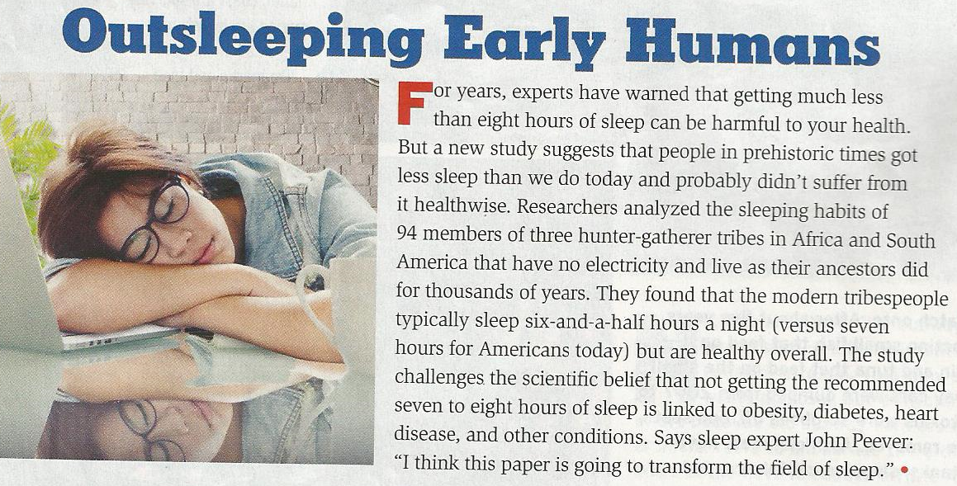

During Reading: What are your thoughts as you read? Note at least 1 idea making sure to quote the particular section you are referencing. What makes this idea notable? Be thoughtful in your remarks.

After Reading: What are your thoughts in response to these study’s findings? Explain using specific references from the text.

Taking it Further: Look back at your survey responses. What could be done in reflection of your sleeping situation? Be thoughtful in your remarks.

Re-Think It! Do you get enough sleep? YES NO

