Name ______________________________________ Period _____ Date __________________________
Persuasion
Directions: Use the textbook (pages 247, 249, 252, and 362-363) to complete the notes over persuasion.

Write the definition of nonfiction:

After writing the definition, HIGHLIGHT the words and phrases that indicate your understanding of persuasion whether cajoling or genuine.

What is the purpose of persuasive writing? “_____________ are often times persuasive, given to encourage a certain ________________ or to ______ the listener over to a _____________.”

“If the author’s purpose is to persuade, determine whether the author is presenting an _______________ , emotional ________, or a ________________________ of both.”
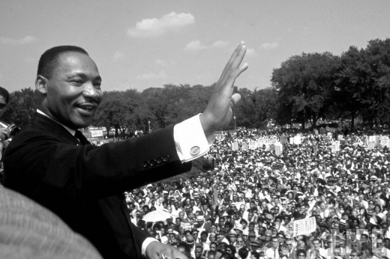

Read the excerpt from Martin Luther King, Jr.’s speech
on page 249. What is the purpose of his speech?
“Argument relies on
1.
2.
3.
in order to convince the reader of the
____________ of a claim.”

“Evidence may consist of King uses ____________ in his speech as seen in the
1. excerpt. What type of appeal is this? ______________
2.
3.
and may also consist of various types of appeals.”

What makes a message convincing?

“Creators of persuasive works use various _________________ to sway readers, but all persuasion shares one element: ____________________.”
Argument is _____________________________________________________________________.
The statement is called the _______________________ which is usually in the form of a _____________ sentence (pg. R53 - a sentence that ________________________________ and end with a __________).

Proposition: “A good proposition should be _______________[: a speaker must be able] to present _______________ for or ______________ it.”

Support:
Support for an argument includes…
1. 2.

COUNTER-ARGUMENT is included in ______________________ arguments.
Counter-argument is

Draw and label the graphic on page 362 below.
Define the THREE APPEALS:
1. LOGIC (logos)

2. EMOTIONAL (pathos)

3. ETHICAL/AUTHORITY (ethos)

Define each of the following:
LOGIC INDUCTIVE REASONING DEDUCTIVE REASONING

Rhetorical devices use __________________ to enhance persuasion.
- Parallelism –

Example from Anthony’s excerpt:

