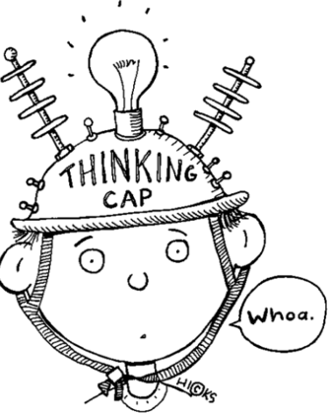
Writing the
Thesis Statement
Step One: Choose your topic.

Step Two: State your stance. What is your opinion?

Step Three: Give your rationale for your stance.
- __________________________________________________________________________________________________________________

- __________________________________________________________________________________________________________________

Step Four: Qualify your stance.

Step Five: COMBINE the topic, rationale, and qualification (more room on back if needed).

Step Six: CHECK your statement.
Is your statement…
Specific? Debatable?
Unified? Relevant?
Writing the
Thesis Statement
Step One: Choose your topic.

Step Two: State your stance. What is your opinion?

Step Three: Give your rationale for your stance.
- __________________________________________________________________________________________________________________

- __________________________________________________________________________________________________________________

Step Four: Qualify your stance.

Step Five: COMBINE the topic, rationale, and qualification (more room on back if needed).

Step Six: CHECK your statement.
Is your statement…
Specific? Debatable?
Unified? Relevant?

